From http://www.lasercannon.com/cvt.htm on 2007/02/14.

The CVT is not new to the US and has been around a long time in Europe. Subaru introduced this technology first into the US and suffered horribly. Audi now offers a CVT on some of their vehicles in the US. But most importantly, Nissans CVT used on the Murano and other previous vehicles overseas is based on a steel belt. So this CVT is based on a solid foundation.
For those that do not understand what a CVT is, the CVT has no gears. Nissans CVT uses variable cone shaped pulleys and a segmented steel belt as opposed to a hydrostatic or toroidal solution. The CVT therefore has an infinitely variable ratio between it's lower and upper ratio limits. No more jerking when the gears pop into place, because there are none. Also, the CVT allows the engine to rotate at it's torque max for best performance. at a lower rpm for economy, or anywhere in between. No more gear hunting when driving up hills.
The CVT in the Murano is a Van Doorne push belt type manufactured by JATCO. CVTs are presently used in over 40 vehicles overseas, built by several manufacturers and have been used for years.
ZF(ST) | GM | FHI | JATCO | Toyota | Honda
  Rover 25 1.8L | 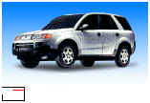  Saturn Vue 2.2L | 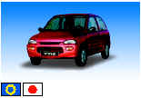  Subaru Vivio 0.66L |   Nissan Liberty 2.0L |   Toyota Opa 2.0L | 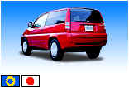  Honda HR-V 1.6/1.7L
  Rover 45 1.8L | 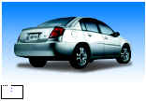  Saturn Ion 2.2L |   Nissan Micra 1.3L [till 2002] |   Nissan Wingroad 2.0L |   Toyota Allion 2.0L | 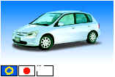  Honda Civic 1.5/1.7L
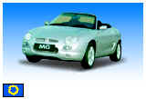  MG TF 1.8L |   Opel (Vauxhall) Vectra 1.8L (From end 2003) |   Subaru Pleo 0.66L | 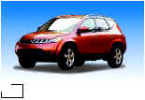  Nissan Murano 3.5L | 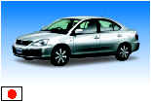  Toyota Premio 2.0L | 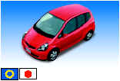  Honda Fit/Jazz 1.3/1.5L
  Mini One & Cooper 1.6L |  | 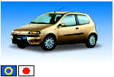  Fiat Plunto 1.2L | 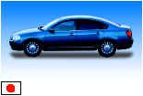  Nissan Teana 3.5L | 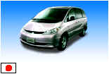  Toyota Estima Hybrid 2.4L (100% CVT) | 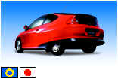  Honda Insight Hybrid 1.0L
  Ford Focus C Max 1.6L TDCi |  | 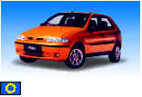  Fiat Palio 1.2L | 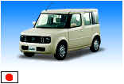  Nissan Cube 1.3L | 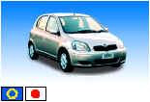  Toyota Vitz (Yaris) 1.3L | 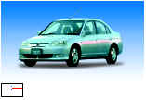  Honda Civic Hybrid 1.3L
 |  |   Lancia Y 1.2L | 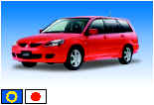  Mitsubishi Lancer/Wagon 1.5/1.8L | 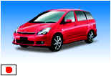  Toyota Wish 2.0L |   Honda Mobilio 1.5L (100% CVT)
 |  | 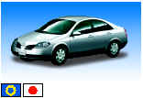  Nissan Primera 2.0/2.5L | 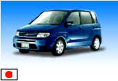  Mitsubishi Dingo 1.5L [till 2002] |  |   Honda Odyssey 2.4L
 |  |   Nissan Serena 2.0L | 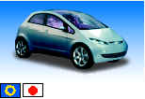  Mitsubishi Colt 1.3/1.5L (100% CVT)
 |  | 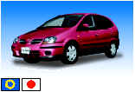  Nissan Almera (Tino) 2.0/2.5L [till 2002] |   Hyundai Sonata 1.8/2.0L
 |  | 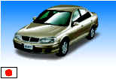  Nissan Bluebird Sylphy 2.0L | 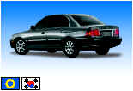  Kia Optima 1.8L

Nissan Avenir 2.0L

Nissan R'nessa 2.0/2.5L [till 2003]

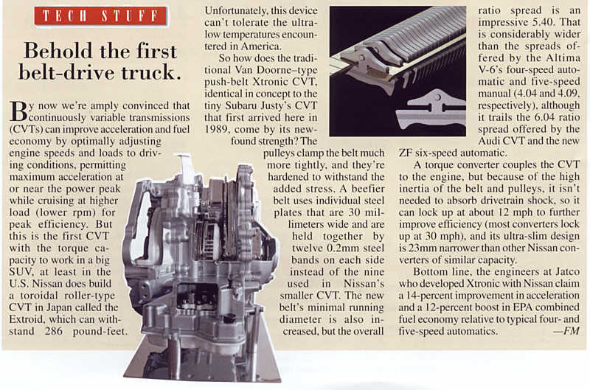
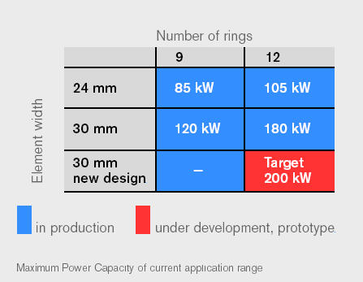
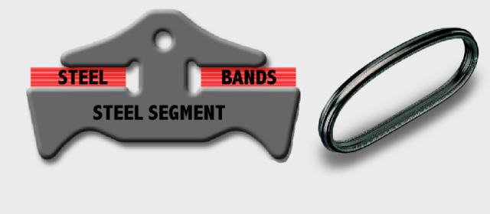
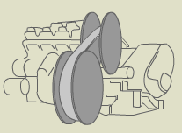
Out of the blue you occasionally get an email that is actually worth while and not a load of spam. That happened to me recently. Out of the blue I received an email and some documents from a person that visited my website. I will not post or email the proprietary documents or this persons contact info, it would not be right to put someone on the spot and take their info out of context. This person has been very gracious answering my questions. So I will share some of the questions and answers.
The first document talks about the Van Doorne push-belt CVT with reference to the one used in the Murano. It talks about the materials and processes used and how to maximize them given the finite element analysis of stresses and test data. Good enough to know that a lot of science and engineering went into the CVT. The second document was a brochure showing all the vehicles that currently use CVTs. They are quite common and have been for years overseas, pertinent info posted above. The last document talks about a prototype CVT for V8s (580Nm+). Bottom line it worked and we could start seeing them in vehicles as large as the GMC Yukon.
Here are some of the questions I asked and the replies:
Q: The max belt tension is 500Nm and the engine currently produces 350Nm+. So if engine modifications are performed that increase the power output, does this effectively result in a shorter lifetime of the belt?
A: The belt is designed based on a certain load collective. In case you increase the power output of the engine and actually use this extra power a lot, you will change the load collective and consequently change the life time of the belt.
Q: And I doubt it is this simple, but does it mean the CVT is capable of something less than 500Nm? IE the margin on the CVT is 150NM?
A: The CVT is capable of a lot more but it is a trade off between lifetime and torque capacity. We have even put it in a Formula one vehicle that was tested by David Coulthard in 1993. The belt lasted about two races. The CVT system was however not allowed to be used in the race. At this moment the 350 Nm is kind of a maximum torque capacity for commercial available vehicles of which your Murano is a nice example. We are working to increase this number. The reason why it must be able to handle 500+ Nm is that the Murano has got a torque converter that is able to amplify the engine torque to these levels. The time share of this event in the load collective is however small. The 350 Nm does outnumber the chain that is used by Audi (maximum 310 Nm and no torque converter so no torque amplification).
Q: How does one derive the predicted lifetime of the belt if a constant 350Nm is applied? Am very interested in this one as I am preparing to tow a trailer right at the 3500lb TOW rating of the Murano for 700 miles in one day.
A: Unfortunately there is no simple formula for this one. It depends on a lot of factors. In case you stay within the margins described in your manual you are safe.
Q: Am I correct in assuming that the CVT is designed such that the belt does not slip with respect to the pulleys?
A: Technically speaking the belt always slips because of the tribological nature of the contact between belt and pulley. We call this microslip. In case it becomes macroslip it becomes a problem and damage can occur. The pressure force is controlled in a way that macroslip can not occur by using a certain safety factor. (A nice paper on this subject is SAE paper number 980822 from Nissan, available at www.sae.org)
Q: Am I correct in assuming the CVT controllers are designed to prevent jerk? In other words, what holds the belt in place is static friction which means the CVT can handle velocity and acceleration but not jerk which might overcome the static friction force and cause the belt to slip with the resulting dynamic friction, heat buildup and materiel weakening/loss?
A: The controllers are designed to handle jerk coming from the engine side. Jerk coming form the road side is handled by the clamping safety (see above).
The first document was released during the VDI 2002 CVT congres in Munich Germany (VDI No 1709, ISBN 3-18-091709-1).
Additional SAE papers (these can be obtained from the site www.sae.org at some cost) about CVT's in the Nissan Murano, Primera, Saturn Vue and Ford Focus: Primera : 980823 Toyota : 2000-01-0872 ZF :2000-01-0873 Murano : 2003-01-0593 Saturn Vue : 2003-01-0593
References: [1] Brandsma, A., van Lith, J,. Hendriks, E., "Push belt CVT developments for high power applications", Proc. of CVT99, Eindhoven University of Technology 1999, pp.142-147. [2] van der Sluis, F., Brandsma, A., "Stress reduction in push belt rings using residual stresses", Proc. of CVT2002, VDI, Munich 2002, pp.383-402. [3] Stockton, T., "The Ford research dual mode Continuously Variable Transmission”, Proc. of SAE 1984, SAE841305. [4] Markland, E., Comerford, K., "Dual mode improves CVT efficiency”, Professional engineering, July-August 1991, pp. 27-28. [5] Mucino, E., et al., "A continuously Variable Power Split Transmission for Automotive Applications”, Proc. of SAE Detroit 1997, SAE970687. [6] Heitmann, A., et al., "Das i2 Getriebe für den Autarken Hybrid”, Proc. of VDI, 1995, VDI Berichte nr 1225 pp. 101-114.

Although it's not the Xtronic, the JATCO toroidal is the "Nissan Xtroid". Here is an interesting read on the maker of both CVT's, namely JATCO. Unfortunately their site provides a lot of detail on the toroidal CVT but not the Xtronic.
A white paper was presented at the Japan Society Of Automotive Engineers on the JATCO belt drive CVT3 designed for a front wheel car with 3.5L ie MO. But I can't find the actual document! There are also a few interesting reads at the Engineering Tips Forums.
From my research, the change in the belt and cone materials and most importantly the fluid led to the development of the JATCO CVT3. Fascinating stuff.
Nissan is being careful not to over emphasize the CVT in their marketing of the Murano even though they have spent lots of money in the development of the technology over a couple decades, have used it for years in "foreign" markets, and some racing. I believe the reluctance is not due to the engineering, I believe it's due to the "American Market". Our reluctance to embrace new ideas, especially given the Subaru experience. We tend to not let the facts get in the way, urban legends are much more important after all.

